Nama : Ade Kurniawan

NIM : 18090088

Kelas : 5D

Laporan Praktikum 2

1. Source Code

Model_latihan1.php -> application\models

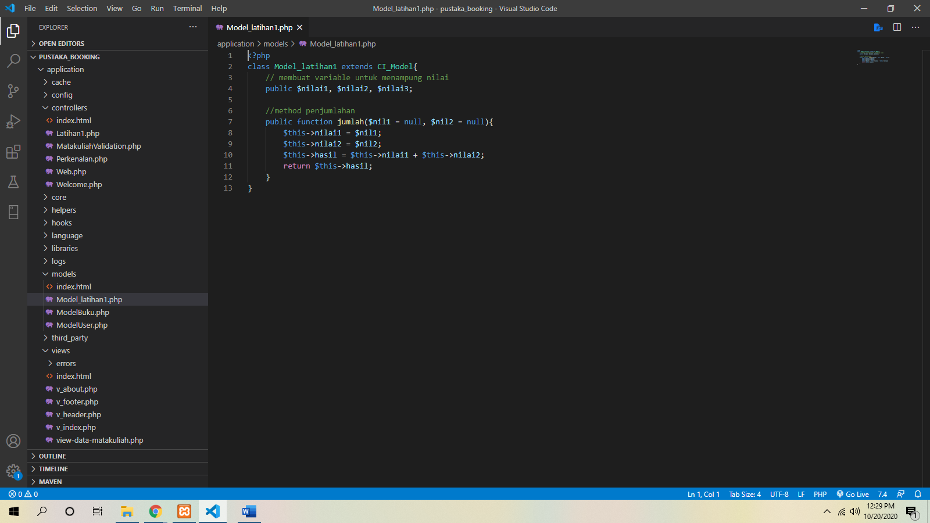

Latihan1.php -> application\controllers

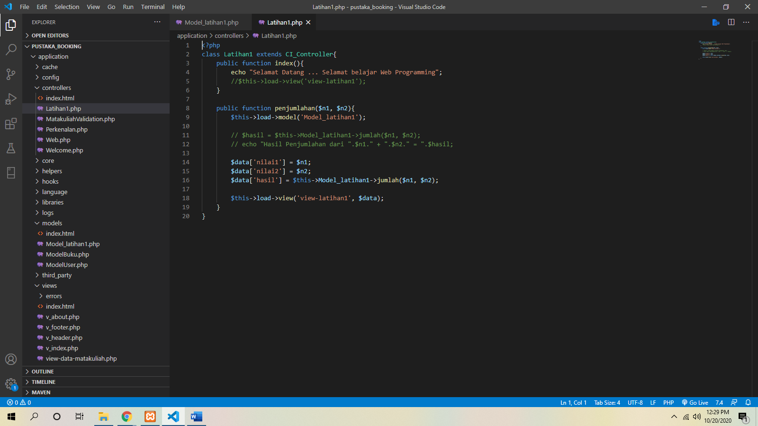

View_latihan1.php -> application\views

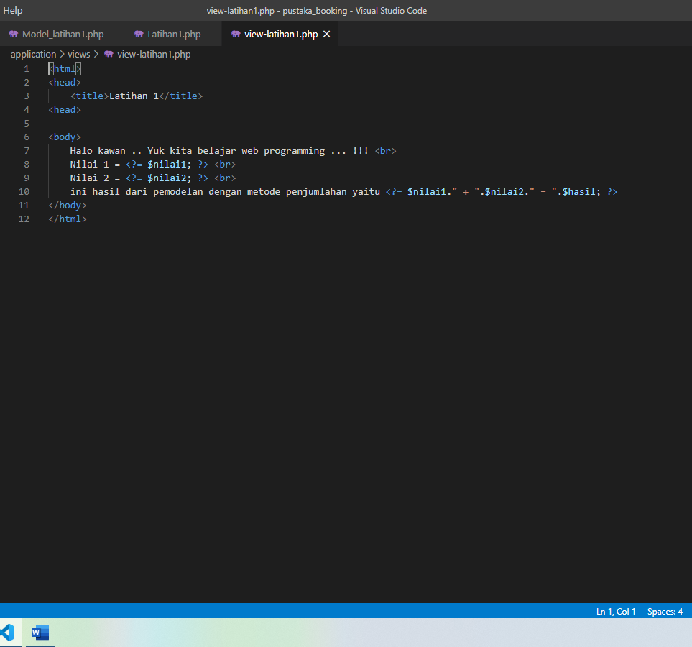

1. URL

<http://localhost/pustaka-booking/index.php/Latihan1>

<http://localhost/pustaka-booking/index.php/Latihan1/penjumlahan/5/5>

1. Capture Output Program

